Project Server and Visual Studio Team System Integration: User Guide

Contents
Glossary of Terms 2
Introduction 3
Project Synchronization Scenario 3
Creating a team project in Visual Studio Team System 3
Deleting a team project in Visual Studio Team System 8
Deleting an enterprise project plan in Project Server 10
Assignment Synchronization Scenario 15
On-demand assignment synchronizing from Project Server to Visual Studio Team System 16
On-demand work item synchronizing from Visual Studio Team System to Project Server 16
Creating a work item in Visual Studio Team System 16
Updating a work item in Visual Studio Team System 21
Creating an assignment in Project Server 28
Updating an assignment in Project Server 35
Deleting an assignment in Project Server 37
Resource Synchronization Scenario 38
On-demand resource synchronizing from Project Server to Visual Studio Team System 39
On-demand resource synchronizing from Visual Studio Team System to Project Server 39
Adding a resource in Visual Studio Team System 39
Deleting a resource in Visual Studio Team System 48
Adding a resource in Project Server 51
Troubleshooting 56
Creating a Team Project 56
Deleting a Team Project 57
Deleting an Enterprise Project Plan 58
On-demand assignment synchronization from Project Server 58
On-demand work item synchronization from VSTS 59
Creating a work item in VSTS 59
Updating a work item in VSTS 60
Creating an assignment in Project server 61
Updating an assignment in Project server 61
Deleting an assignment in Project server 62
Synchronizing Reports 62
Generating Feature Crew Report 63
On-demand resource synchronization from Project Server 64
On-demand resource synchronization from VSTS 65
Adding a resource in VSTS 65
Deleting a resource in VSTS 66
Adding a Resource in Project Server 66

Glossary of Terms
The following table lists the abbreviations and acronyms used in this document.
VSTS | Visual Studio Team System
TFS | Team Foundation Server
API | Application Programming Interface
PCW | Project Creation Wizard
EPM | Enterprise Project Management
UI | User Interface
Config | Configuration
URI | Uniform Resource Identifier

Introduction
This user guide shows the synchronization scenarios between Microsoft® Office Project Server 2003 and Microsoft Visual Studio® 2005 Team System (VSTS). The connector service allows you to synchronize projects, assignments with work items, and resources between Project Server and VSTS.
Each scenario includes a brief description, user roles, preconditions, the procedure, and how to verify the procedure. The troubleshooting section includes tables of problems with causes and solutions.

Project Synchronization Scenario
This scenario covers the functional aspects of the project synchronization when the Team System and Project Server are integrated through the connector service. There is one-to-one mapping between a team project and an enterprise project plan. The following use cases are part of this scenario.
- Creating a team project in Visual Studio Team System
- Deleting a team project in Visual Studio Team System
- Deleting an enterprise project plan in Project Server

Creating a team project in Visual Studio Team System
When Project Server is linked with the Team System then any new team project created in the Team System with the methodology template MSF Agile for Project Server is also created as an enterprise project plan in Project Server. A team project can also be created from an existing project plan in Project Server.
User roles
Project Managers, Administrators
Preconditions
The URL of Project Server and Team Foundation Server are present in the configuration file.
Procedure
To create a team project in Visual Studio Team System:
- Open the Team Explorer. Click New Team Project to launch the project creation wizard.
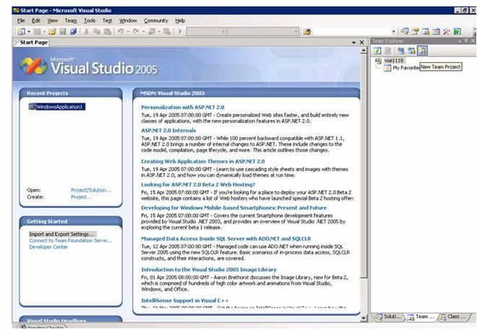
Figure 1. Creating new team project
- In the Specify the Team Project Settings dialog, type the name of the new team project (Figure 2). Click Next.

Figure 2. Specifying team project settings
- In the Select a Process Template dialog, select the methodology template to be applied for this team project from the drop-down list, for example, MSF Agile for Project Server. Click Next.
- In the Select an Enterprise Project Plan for the new Team Project dialog, do one of the following.
- If a new team project is to be created, select the option Create a new enterprise project plan.
- If a team project is to be created and linked to an existing enterprise project plan, select the option Select an existing enterprise project plan and select the name from the drop-down list.
Click Finish.
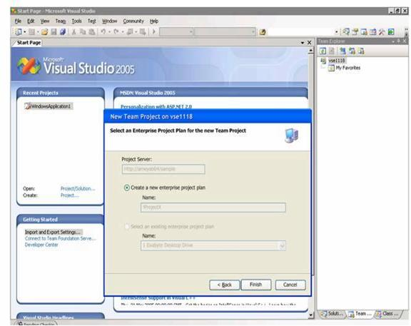
Figure 3. Creating new enterprise project plan
- The new project shows in the Team Explorer (Figure 4).
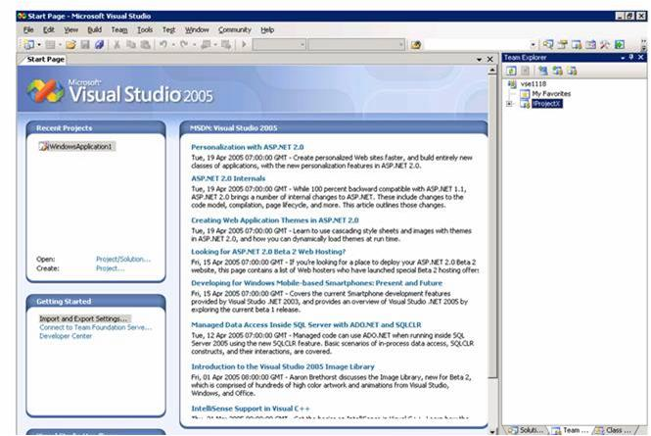
Figure 4. New project created in team explorer
End result and verification
A team project is created in the Team System with the methodology template MSF Agile for Project Server. If it is a new team project then the corresponding enterprise project plan is created in Project Server.
To verify creation of the project in Project Server:
- Start Project Professional and click File → Open.
- Check for the project you created (Figure 5).

Figure 5. Projects in Project Server

Deleting a team project in Visual Studio Team System
After the initial synchronization process is completed and Project Server is synchronized with the Team System, then any team project based on MSF Agile for Project Server deleted in the Team System is unlinked with the corresponding enterprise project plan in Project Server.
User roles
Project Managers, Administrators
Preconditions
The URL of Project Server and Team Foundation Server are present in the configuration file. That is, the team project is linked with an enterprise project plan in the configuration database.
Procedure
To delete a team project in Team System:
- Open a Visual Studio Command Prompt and change the directory to the active Microsoft Visual Studio directory. For example, C:\Program Files\Microsoft Visual Studio 8\VC

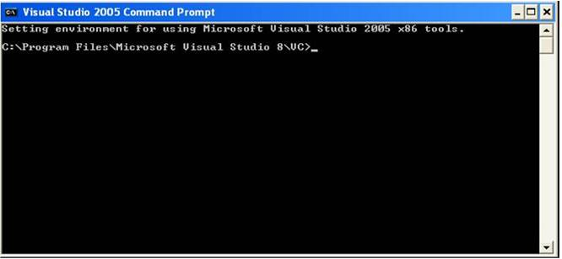
Figure 6. Visual Studio Command Prompt
- Type the following command to set the path:
PATH=%ProgramFiles%\Microsoft Visual Studio 8\Common7\IDE\PrivateAssemblies
- Type the command DeleteTeamProject projectname. This command asks the user to confirm deletion. Press Y to delete the project and all its components.
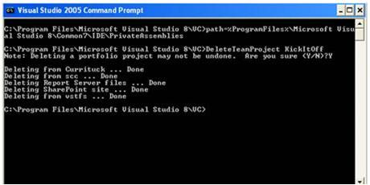
Figure 7. Deleting project through Command Prompt
End result and verification
The team project in Team System is unlinked from the enterprise project plan in Project Server.
To verify, open the configuration database in the SQL database. The IsDeleted column of the EntProjTeamProjAssoc table is set to 1.

Deleting an enterprise project plan in Project Server
After the initial synchronization process is completed and Project Server is synchronized with the Team System, when you delete any enterprise project plan that is tagged isLinked in Project Server, that project is unlinked from the corresponding team project in VSTS.
User roles
Project Managers, Administrators
Preconditions
The URL of Project Server and Team Foundation Server are present in the configuration file. That is, the team project is linked with an enterprise project plan in the configuration database.
Procedure
To delete an enterprise project plan in Project Server:
- Open Microsoft Office Project Web Access and log on as an administrator.
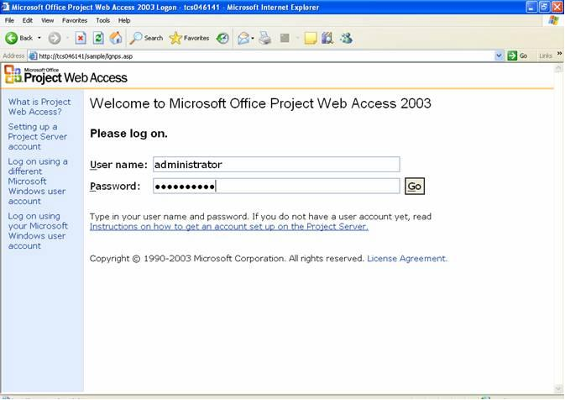
Figure 8. Logging on to Project Web Access
- On the Project Web Access Home page, click Admin.
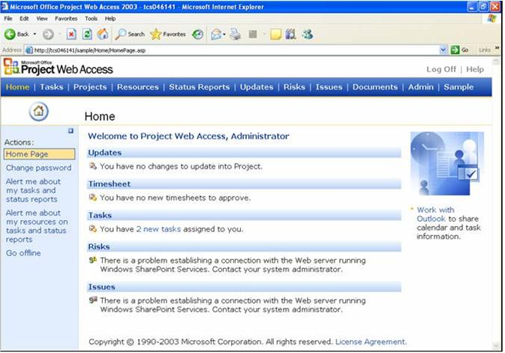
Figure 9. Project Web Access home page
- On the Administration Overview page, click Clean up Project Server database in the left pane (Figure 10).
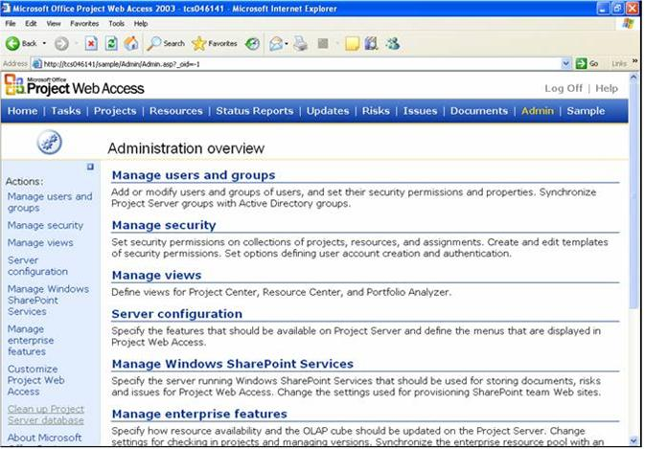
Figure 10. Administration overview in Project Web Access
- Click the Project and To-do Lists option and then select the enterprise project plan to be deleted by clicking the Name cell (Figure 11).
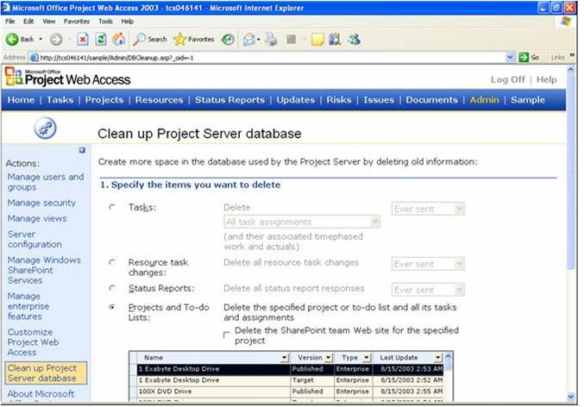
Figure 11. Deleting a project plan (screen 1)
- Scroll down and click Delete (Figure 12).
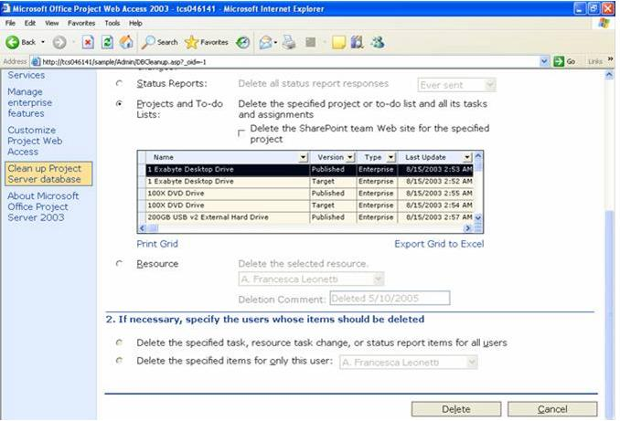
Figure 12. Deleting a project plan (screen 2)
- In the confirmation dialog, click Yes to delete the selected enterprise project plan.
End result and verification
The project plan in Project Server is unlinked from the team project in Team System. The IsLinked column is set to No in the configuration database for the project row.
To verify deletion of the project plan, click Projects to display a list of the existing projects (Figure 13).
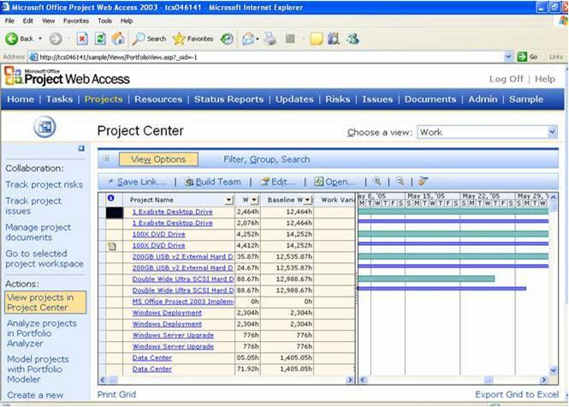
Figure 13. Project center in Project Web Access

Assignment Synchronization Scenario
This scenario covers the synchronization of work items on the Team System and and assignments on Project Server when the systems are integrated through the connector service. There is a one-to-one mapping between a work item and an assignment. The following use cases are part of the assignment synchronization scenario.
- On-demand assignment synchronizing from Project Server to Visual Studio Team System
- On-demand work item synchronizing from Visual Studio Team System to Project Server
- Creating a work item in Visual Studio Team System
- Updating a work item in Visual Studio Team System
- Creating an assignment in Project Server
- Updating an assignment in Project Server
- Deleting an assignment in Project Server

On-demand assignment synchronizing from Project Server to Visual Studio Team System
On-demand assignment synchronization explicitly synchronizes assignments from Project Server to the Team System, for assignment in Project Server with the enterprise custom field isLinked set to Yes that does not have an existing corresponding work item in the configuration database. The assignment is added as a work item in the associated team project in Visual Studio Team System.
User roles
Administrators
Preconditions
Assignments with the isLinked field set to Yes exist in Project Server that do not have corresponding work items in the Team System.
End result and verification
Work items are created in the Team System for assignments in Project Server.

On-demand work item synchronizing from Visual Studio Team System to Project Server
On-demand work item synchronization explicitly synchronizes work items from Team System to Project Server, for any work item in the Team System that has an enterprise custom field Sync set to Yes and that does not have a corresponding assignment in the configuration database. The work item is added as an assignment in the associated enterprise project plan in Project Server.
User roles
Administrators
Preconditions
Work items exist in the team project that do not have corresponding assignments in the project plan.
End result and verification
Assignments are created for the work items.

Creating a work item in Visual Studio Team System
When a work item is created with a Sync field set to Yes and the projects are linked, a corresponding assignment is created in a specified project plan on Project Server.
User roles
Project Managers, Team Members
Preconditions
Projects in Project Server and Visual Studio Team System are linked in the connector database.
Procedure
To add a work item in Visual Studio Team System,
- Open Visual Studio 2005 and select any project in the Team Explorer. Right-click on the project name and click Add Task.
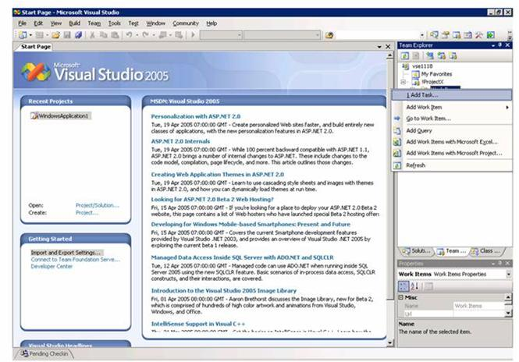
Figure 14. Adding new task
- Fill in the appropriate information in the Task tab (Figure 15). Click File → Save to save the changes.

Figure 15. Filling in task details
End result and verification
A work item with a corresponding assignment is created in the specified project plan on the Project Server.
To view the assignment in Project Server:
- Open Project Web Access and log on as Administrator (Figure 8).
- On the Home page, click Updates on the horizontal menu bar (Figure 10).
- In the View task changes submitted by resources page, click Accept All (Figure 16).
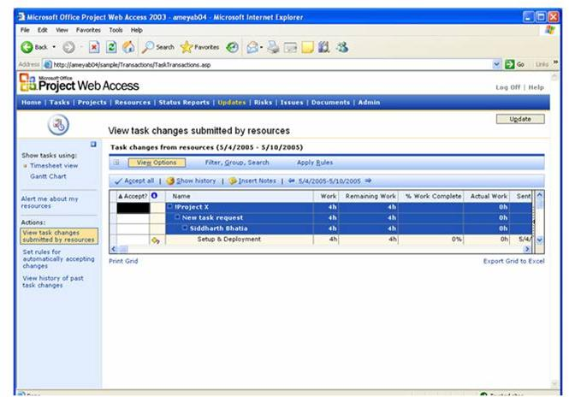
Figure 16. Viewing task changes in Project Web Access
- Click Update.
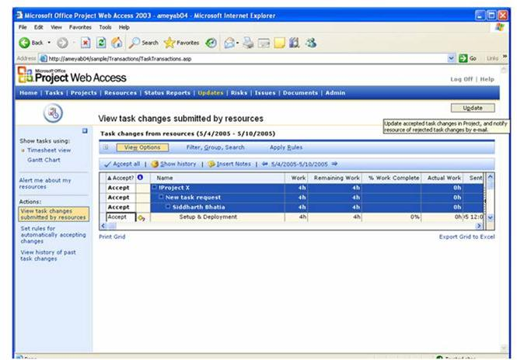
Figure 17. Accepting all task changes
- Click OK in the confirmation message box (Figure 18).
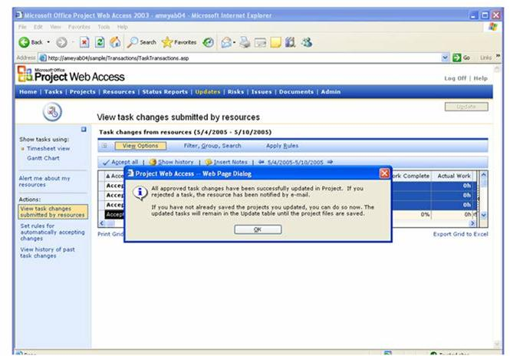
Figure 18. Confirming acceptance of task changes

Updating a work item in Visual Studio Team System
The work item contains many fields that are mapped to the assignment fields in Project Server. The business rules are different for each of the fields when they are updated.
Note For information about the business flow, see Detecting the changes in the Project Server database (detailed mechanism) in the document Integrating Project Server 2003 with Visual Studio 2005 Team System.
When any work item field is changed, the corresponding field in the assignment is also changed in Project Server. Only those work items that have Synch=Yes, and have corresponding assignments get updated.
User roles
Team Members
Preconditions
The work item and the assignments are linked in the connector database and have Synch=Yes and isLinked=Yes.
Procedure
To update a work item in Visual Studio Team System:
- Open Visual Studio 2005 and the Team Explorer pane (Figure 19). Select a project, expand My Queries and double-click My Tasks.
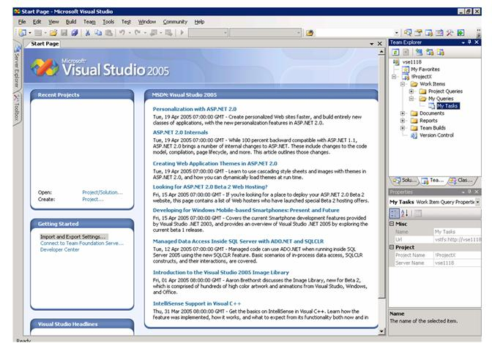
Figure 19. Selecting My Tasks in VSTS Team Explorer
- In the My Tasks (Results) tab, select the work item and type the appropriate information in the fields. Click File → Save.
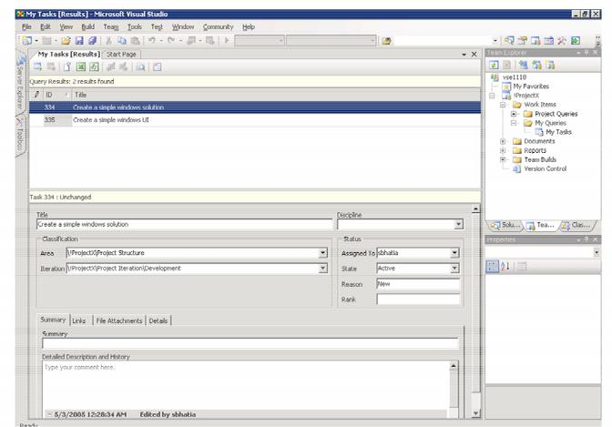
Figure 20. Viewing My Tasks details
- The Team Explorer tab changes focus to the Solution Explorer tab. In the Pending Checkin pane (in the lower half of the main window, Figure 21), click Check In.
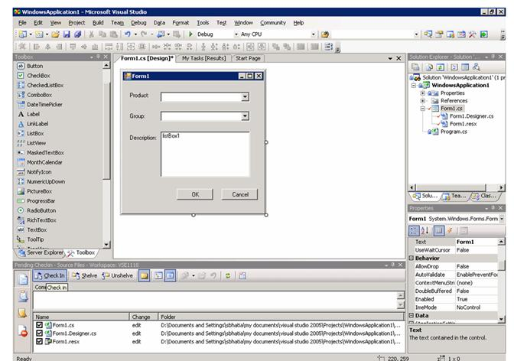
Figure 21. Pending Checkin pane opened from the Solution Explorer view
- In the Policy Failure message box, check Override policy failure and continue checkin and then click OK (Figure 22).
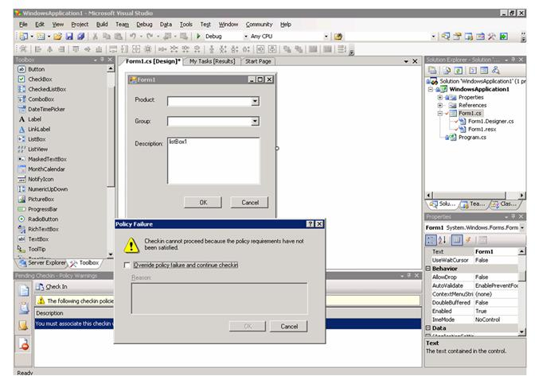
Figure 22. Policy Failure message box
- In the Pending Checkin pane, select My Tasks in the Query drop-down list.
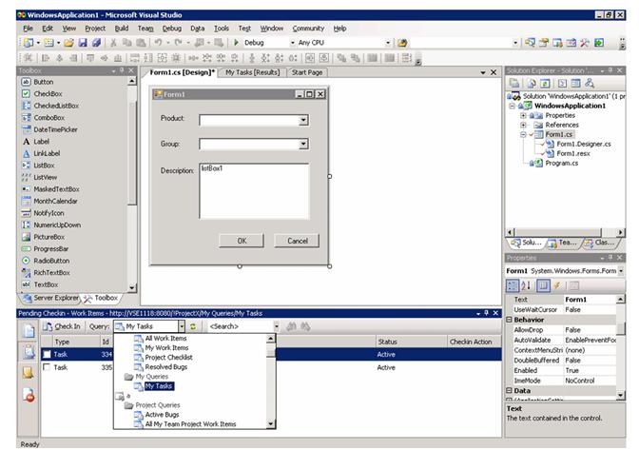
Figure 23. Selecting My Tasks in the Pending Checkin pane
- Select the Task check boxes in the Pending Checkin pane. Select Resolve in the CheckIn Action column.
- Click the Details tab in the main window (Figure 24) and type the appropriate value in Completed Work (hours).
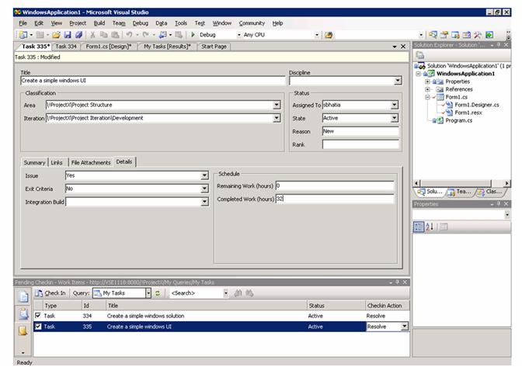
Figure 24. Modified task details
End result and verification
The assignment is updated for a specified property of the work item.
To view the updated work item in the Project Server:
- Log on to Project Web Access as an administrator (Figure 8).
- One the Home page, click Updates on the menu bar (Figure 10).
- The View task changes submitted by resources page show the updated status. Click Accept All (Figure 17).
- The Accept column shows the Accept status.
- Click OK on the confirmation message box (Figure 18).
- Open Project Professional. The new updates are shown in the Tasks view (Figure 25).
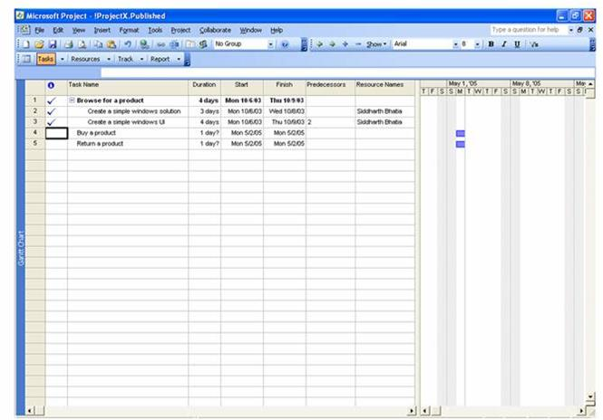
Figure 25. Opening Project Professional

Creating an assignment in Project Server
When the project plan is linked with a team project, and a new assignment with custom field isLinked set to Yes is created and approved by the project manager then the corresponding work item is created with Synch set to Yes and Approved set to Yes.
User roles
Project Managers
Preconditions
The Project Server and Team System are linked in the configuration file. The team project is linked with an enterprise project plan in the configuration database.
Procedure
To add an assignment in Project Server:
- Open Project Professional, connect to Project Server (Figure 26), and log on.
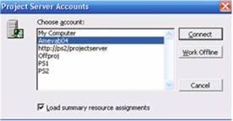
Figure 26. Selecting Project Server account
- Click a task name and the Open dialog appears with the list of projects available on Project Server (Figure 27). Select a team project created in VSTS.
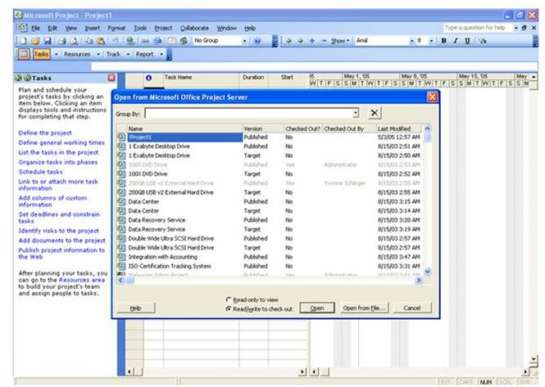
Figure 27. Projects in Project Server
- Insert a new column in the task grid. On the Insert menu, click Column, and then type Work Item ID for the name of the new column. Figure 28 shows the new Work Item ID column in the grid.

Figure 28. Work Item ID column added
- Type the new tasks and the corresponding task values (Figure 29).
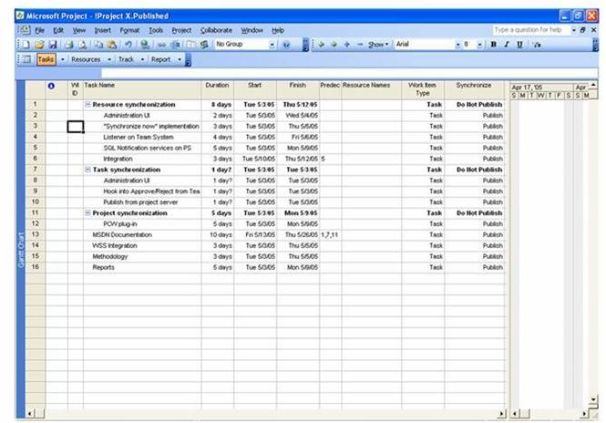
Figure 29. Adding new tasks
- On the Tools menu, click Build Team from Enterprise.
- In the Build Team for <Project name> dialog, type and select the filtering criteria to retrieve the resources marked as VSTS resources. Click Apply Filter. Select and drag the resources you want to the Project Team Resources list and then click OK (Figure 30).
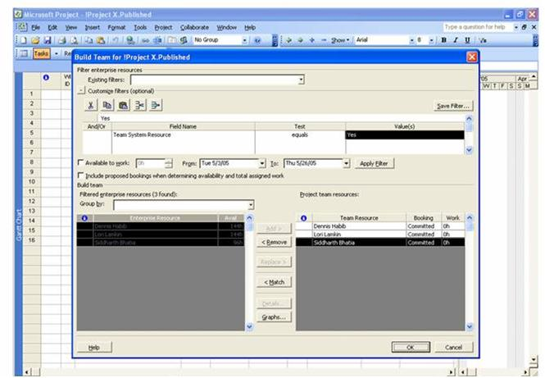
Figure 30. Selecting filtering criteria to build team
- Select a resource from the drop-down list in the Resource Names column in the task grid (Figure 31).
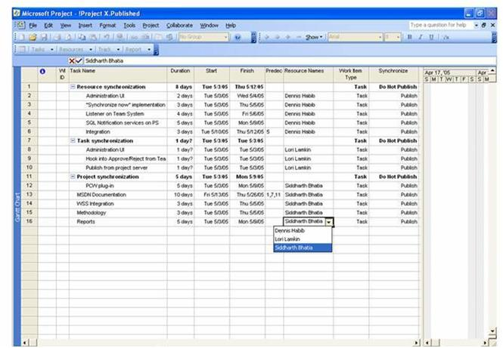
Figure 31. Selecting a resource in Project Professional
- On the Collaborate menu, click Publish → All Information. The Tasks view shows the work item ID information for each task (Figure 32).
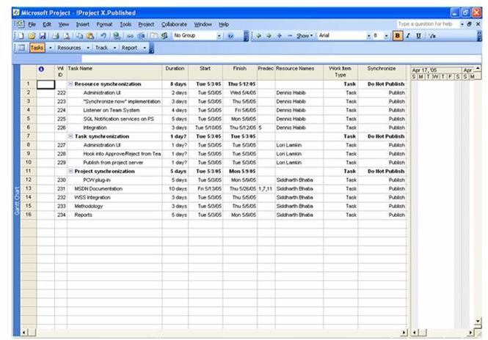
Figure 32. Viewing work item ID for all tasks
End result and verification
For the new approved assignment in Project Server, the connector creates a corresponding work item in the Team System.
To view the added assignment in Team System:
- Start Visual Studio 2005, open the project, and then click Work Items → My Queries → My Tasks in the Team Explorer (Figure 19).
- The My Tasks query results shows all work items assigned to the user (Figure 33).
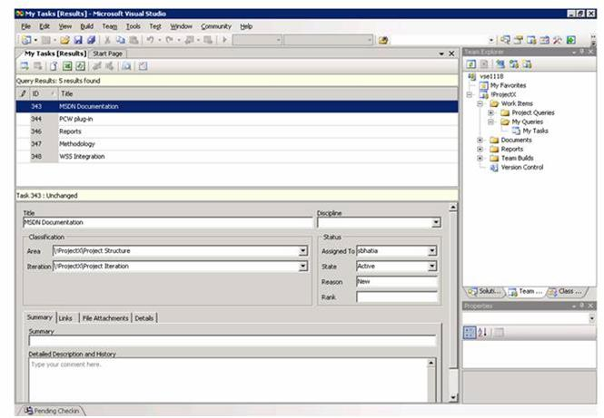
Figure 33. Lists of tasks for a resource

Updating an assignment in Project Server
After Project Server is synchronized with the Team System, then the connector updates corresponding Project Server assignments and Team System work items. The assignments must be approved and must have the enterprise custom field isLinked set to Yes.
User roles
Project Managers, Team Members
Preconditions
Project Server and Team System are linked in the configuration file.
Procedure
To update an assignment in Project Server:
- Open Project Professional, connect to Project Server (Figure 26), and log on.
- Select a project and click Open.
- In the Task grid, change the value in the Actual Duration column to 1 day (Figure 34).
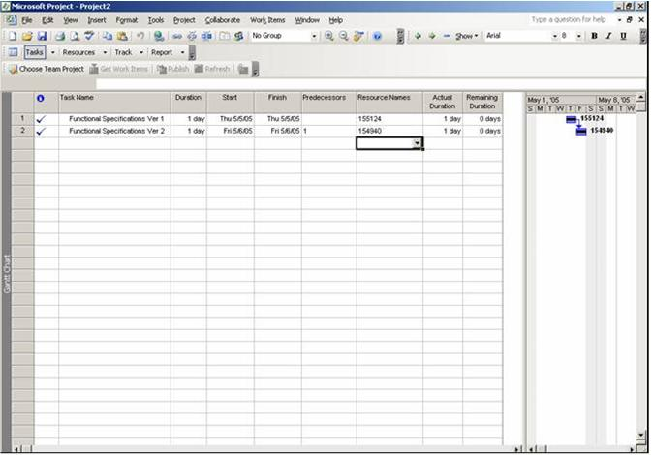
Figure 34. Changing duration of a task
- On the Collaborate menu, click Publish → All Information.
End result and verification
For the assignments that have a changed duration, the corresponding work items are updated in the Team System.
To view the updated assignment in Team System:
- Open Visual Studio 2005 and click Work Items → My Queries → My Tasks in the Team Explorer (Figure 19). The All Tasks (Results) grid displays all of the work items.
- Select a task updated from Project Server. Click the Details tab, and verify that the Remaining Work (hours) and Completed Work (hours) fields are updated in the Schedule area (Figure 35).
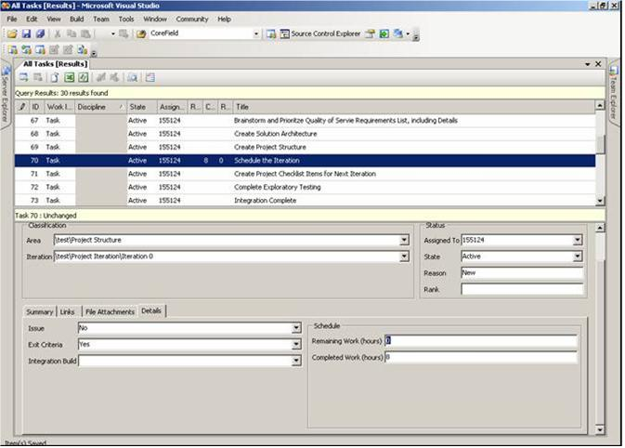
Figure 35. Updating schedule

Deleting an assignment in Project Server
When a linked assignment is deleted in Project Server, it is unlinked from the corresponding work item in the Team System. That is, the Active flag for that record is set to False.
User roles
Project Managers
Preconditions
The Project Server and Team System are linked in the configuration file. The team project is linked with an enterprise project plan in the configuration database.
Procedure
To delete an assignment in Project Server:
- Open Project Professional, connect to Project Server (Figure 26), and log on.
- Select a project that is linked to Team System and click Open.
- In the Task grid, select a task to be deleted.
- On the Edit menu, click Delete Task (Figure 36).
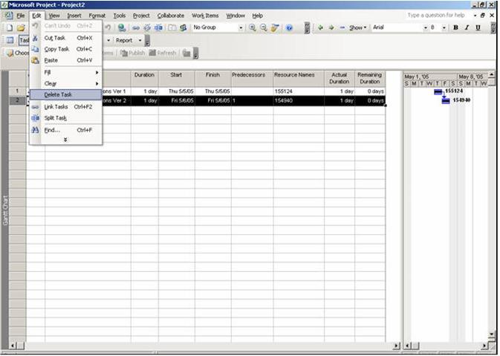
Figure 36. Deleting a task in Project Professional
- A confirmation dialog shows if the task has some actual work recorded for it (Figure 37). Click Yes to delete the task.
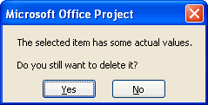
Figure 37. Confirming deletion of a task that has actual work
End result and verification
The assignment in Project Server is unlinked from the work item in the Team System. The Linked column is set to No in the configuration database for the task row.

Resource Synchronization Scenario
The resource synchronization scenario includes the following five use cases when VSTS and Project Server are integrated through the connector service.
- On-demand resource synchronizing from Project Server to Visual Studio Team System
- On-demand resource synchronizing from Visual Studio Team System to Project Server
- Adding a resource in Visual Studio Team System
- Deleting a resource in Visual Studio Team System
- Adding a resource in Project Server

On-demand resource synchronizing from Project Server to Visual Studio Team System
On-demand resource synchronization is a process to explicitly synchronize resources from Project Server to the Team System. The connector adds Project Server resources to the Project Resource group in Team System if the following is true:
- Resources in the enterprise resource pool have the enterprise custom field isLinked set to Yes.
- Those resources are not in the Project Resource group in the Team System.
You can change the Project Resource group name in Team System.
User roles
Administrators
Preconditions
Project Server and Team System are linked in the configuration file. For resources, isLinked is set to Yes, and the resource does not exist in the Visual Studio Team System group.
End result and verification
All the resources tagged as VSTS resources in the enterprise resource pool of Project Server are added to the Project Resource group in the Team System.

On-demand resource synchronizing from Visual Studio Team System to Project Server
On-demand resource synchronization is a process to explicitly synchronize resources from the Team System to Project Server. The connector adds Team System resources in the Project Resources group to the enterprise resource pool of Project Server and sets isLinked to Yes.
User roles
Administrators
Preconditions
Project Server and Team System are linked in the configuration file. Resources exist in the Project Resource group of the Team System. The resource does not exist in the enterprise resource pool.
End result and verification
All the resources in the Project Resource group of the Team System are added to the enterprise resource pool in Project Server.

Adding a resource in Visual Studio Team System
When a resource is added in the Project Resource group in the Team System, the connector also adds it to the enterprise resource pool in Project Server.
User roles
Resource Managers
Preconditions
Project Server and the Team System are linked in the configuration file. The resource should not exist in the enterprise resource pool.
Procedure
To add a resource in Team System:
- Open the Team Explorer in VSTS. On the Tools menu, click Connect to Team Foundation Server. Select a team project and click OK (Figure 38).

Figure 38. Connecting to team foundation server
- Right-click the project in the Team Explorer and click Team Project Settings → Groups (Figure 39).

Figure 39. Opening Groups in the Team Explorer
- In the Project Groups dialog, select the group for which a resource is to be created and then click Properties (Figure 40).
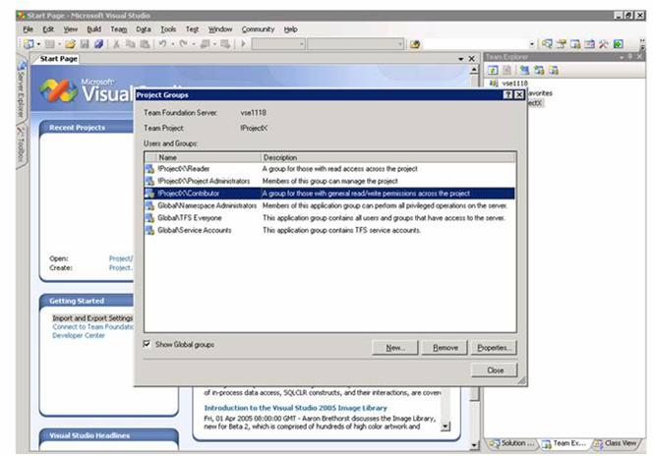
Figure 40. Selecting a group
- Click the Window User or Group option and then click Add (Figure 41).
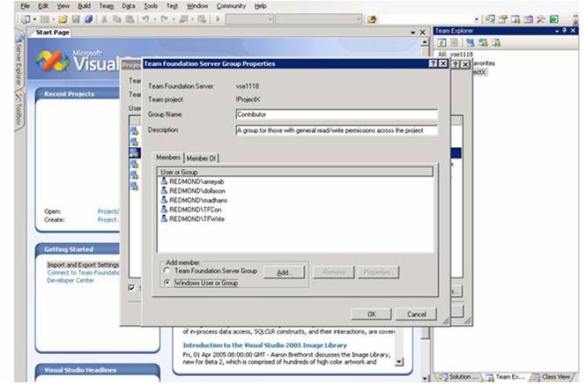
Figure 41. List of resources in the group
- In the Select Users or Groups dialog, type the domain and user name of the resource to be created and click Check Names to see the user ID and location information (Figure 42). Click OK.
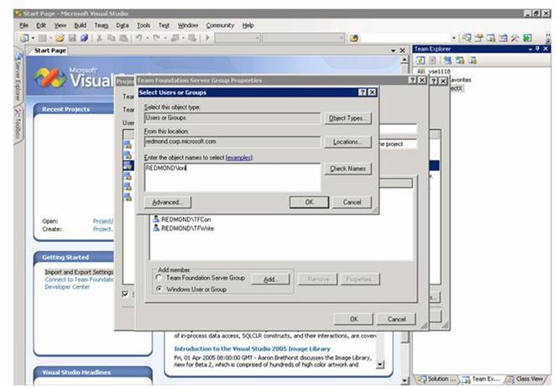
Figure 42. Adding a resource to the group
- If the Multiple Names Found dialog appears, select the resource you want and click OK (Figure 43).
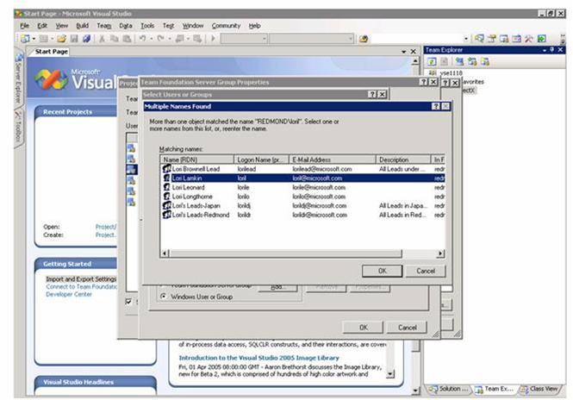
Figure 43. Selecting resource name
- The resource is created in the specified group. Click OK again in the Team Foundation Server Group Properties dialog (Figure 44).
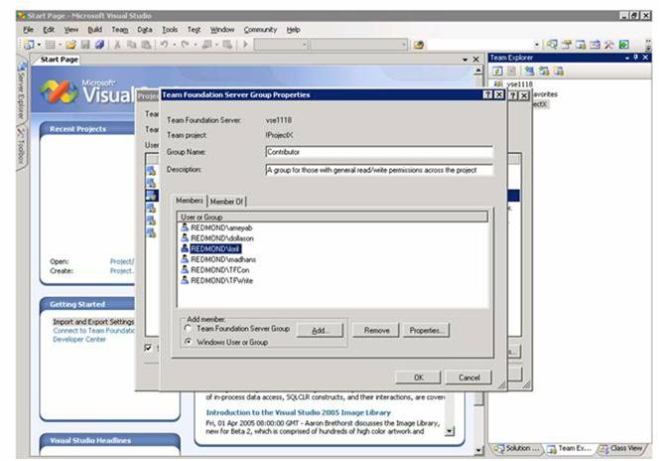
Figure 44. Resource added to group
End result and verification
Resources added in the Project Resource group in the Team System are also added in the enterprise resource pool of Project Server.
To view the added resource in Project Server:
- Open Project Professional, connect to Project Server (Figure 26), and log on.
- On the Tools menu, click Enterprise Options → Open Enterprise Resource Pool (Figure 45).
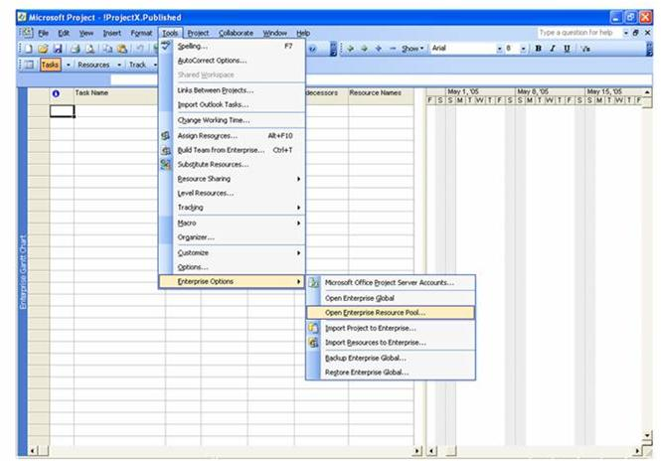
Figure 45. Opening enterprise resource pool
- The Open Enterprise Resources dialog (Figure 46) shows the resources created in the Team System.
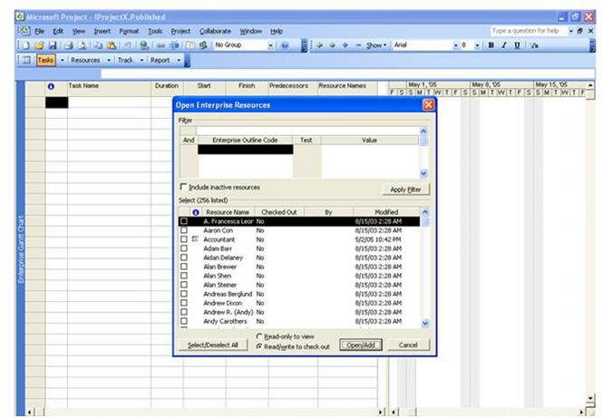
Figure 46. Viewing enterprise resources

Deleting a resource in Visual Studio Team System
When you delete a resource in the Project Resource group in the Team System, the connector sets the enterprise custom field isLinked to No for that resource in the enterprise resource pool in Project Server.
User roles
Resource Managers
Preconditions
The Project Server and Team System are linked in the configuration file. The resource to be deleted exists in the resource group of the Team System.
Procedure
To delete a resource in Visual Studio Team System:
- Open the Visual Studio Team Explorer. Right-click on the server name and select Team Foundation Server Settings → Groups (Figure 47).

Figure 47. Selecting Groups from Team Foundation Server Settings
- In the Global Groups dialog, select a resource group. Click Properties (Figure 48).
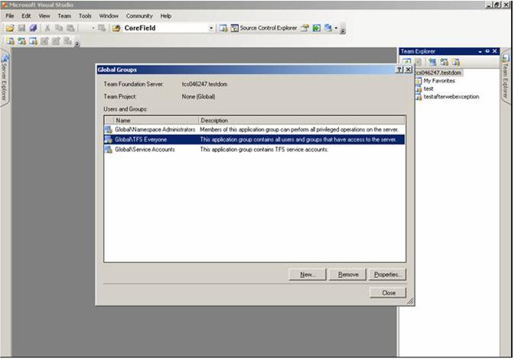
Figure 48. Selecting a group from the list of resource groups
- In the Team Foundation Server Group Properties dialog, select the resource to be deleted and click Remove to delete the resource from that group (Figure 49).

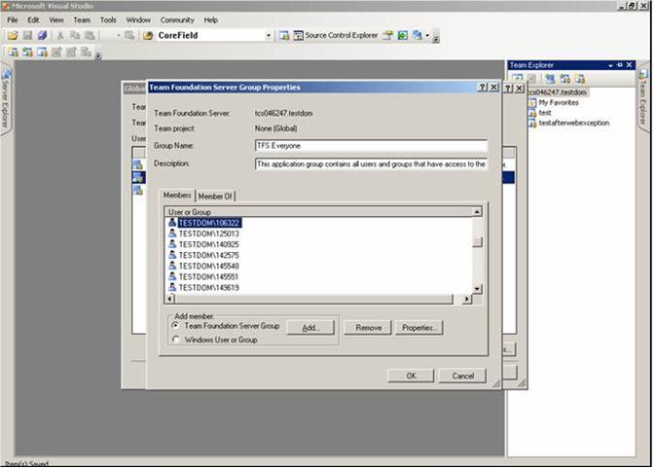
Figure 49. Selecting a resource to be deleted from TFS group
End result and verification
When you delete a resource in the Project Resource group of the Team System, the connector changes the resource enterprise custom field isLinked to No in the Project Server enterprise resource pool.

Adding a resource in Project Server
When you add a resource to the Project Server enterprise resource pool, the connector sets the isLinked custom field to Yes and adds the resource to the Project Resource group of the Team System.
User roles
Resource Managers
Preconditions
The Project Server and Team System are linked in the configuration file.
Procedure
To add a resource in Project Server:
- Open Project Professional, connect to Project Server (Figure 26), and log on.
- On the Tools menu, click Enterprise Options → Open Enterprise Resource Pool (Figure 45).
- In the Open Enterprise Resources dialog (Figure 46), click Open/Add to create a new resource.
- Insert a column in the resource editor. Click the Insert menu and then click Column (Figure 50).
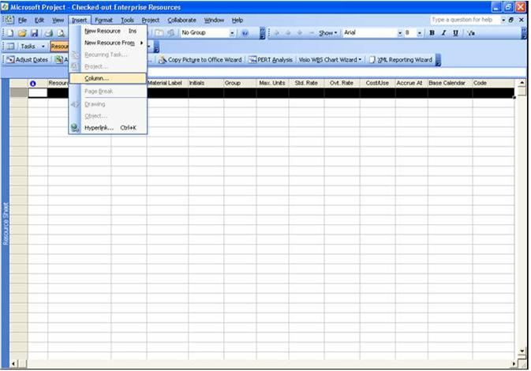
Figure 50. Adding new column to the resource editor
- In the Column Definition dialog, select Windows User Account in the Field Name drop-down list, and then Click OK (Figure 51).
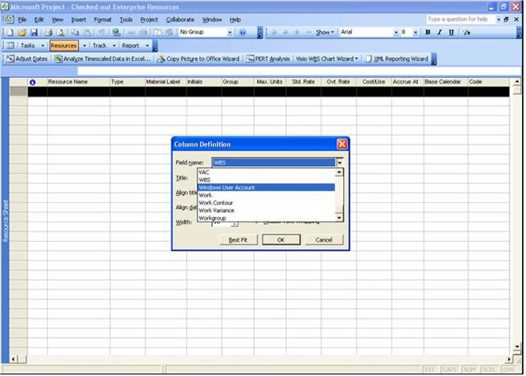
Figure 51. Adding resource column name
- A new field Windows User Account is inserted in the resource editor (Figure 52).
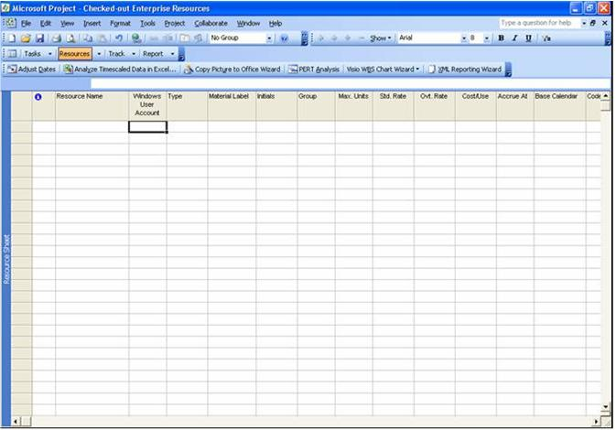
Figure 52. New column Windows User Account added in resource editor
- Similarly, add the custom field Team System Resource in the resource editor (Figure 53). This custom field tags the resource as a VSTS resource. Type the details for the user to be created.
Note An administrator must create the Team System Resource enterprise resource outline code (EROC) in the Enterprise Global project before using the field.
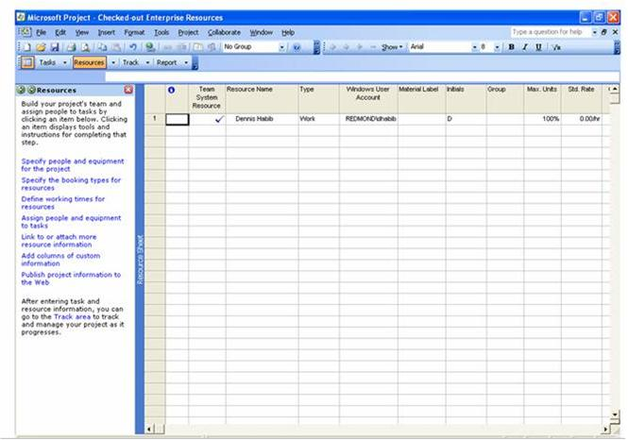
Figure 53. The Team System Resource column and resource details in the resource editor.
- On the File menu, click Save to save the resource in enterprise resource pool.
End result and verification
When a resource is added in the Project Server enterprise resource pool, the same resource is added in the Project Resource group of the Team System.
To view the added resource in Team System
- Open the Team Explorer in VSTS. On the Tools menu, click Connect to Team Foundation Server. Select a team project and click OK (Figure 38).
- Right-click on the project name and select Team Project Settings → Groups.
- In the Project Groups window, select the appropriate resource group (Figure 40), and then click Properties.
- Verify in the Team Foundation Server Group Properties dialog (Figure 41) that the Project Server resource is added to the group.

Troubleshooting

This section covers troubleshooting tips for some of the problems that can occur while using the Project Server and VSTS integrated solution.

Creating a Team Project
Table 1 describes reasons and solutions for problems that can occur while creating a team project in the Team Foundation Server (TFS).
Table 1. Troubleshooting team project creation in TFS
Problem | Reason | Solution
Object reference is not set error message appears while connecting to the TFS through the Visual Studio client. | Team Explorer Plugin is not installed properly. | Check the registry key SOFTWARE\Microsoft\VisualStudio\TeamSystemPlugins\Portfolio Explorer Project Plugins\Team Explorer Plugin. Its value should be 1. If Team Explorer Plugin does not exist, reinstall PCW Plugin.
While connecting to TFS server from a TFS client, the error message The Logon Exception appears. | The user is not in the administrators group in TFS. | Add user to the Namespace Administrators group in TFS.
While creating team project, Retrieving project creation permission failed error message appears in the wizard page Project Creation Status and project creation fails. | The user does not have permission to create team project. | Add the user to the Namespace Administrators group in TFS.
In the wizard page Select A Methodology Template, the selection fails with the error message Bad Plugin found. Choose another methodology template. | PCW Plugin is not properly installed. | Reinstall PCW Plugin.
In Select or Create An Enterprise Project Plan page, the unmapped projects are not present in the drop-down list under Select an Existing Enterprise Project Plan. | 1. IIS is not running properly.  2. Connector Web service is not installed.  3. PDS Extender is not installed. | 1. Restart IIS  2. Install the Connector Web service  3. Install PDS Extender
Microsoft.pcw.rosetta exception is logged while creating a team project. | The user does not have administrator permission on the Report Server. | Go to http://<data tier>/reports, click Properties, and assign the Administrator role to the user.
WSS.WSSPortal failed exception is logged. | The user does not have administrator permission on the Windows SharePoint server. | Add the user in the Windows SharePoint Administrator group in the client tier machine.
Enterprise project plan creation failed message appears in the log file and project is not created on Project Server. | Either the IIS is not running or the Connector Web service is not installed. | Restart IIS or install the Connector Web service if it is not installed.
Unable to Connect to BisService message appears and connection with TFS server fails while connecting to the TFS server from a TFS client. | Either the IIS is not running or TFS Server is not working. | Restart IIS or restart the TFSServerScheduler on the TFS Server.
<Team project name> already exists error message appears in log file while creating team project. | You may be trying to create a duplicate team project. | Create the team project with a different name.

Deleting a Team Project
Table 2 describes reasons and solutions for problems that can occur while deleting a team project.
Table 2. Troubleshooting team project deletion in TFS
Problem | Reason | Solution
You do not have permission to delete the team project error message appears. | Check the permissions of the user. The user must be a namespace administrator, SharePoint administrator and Report server administrator. | Add the user to the Namespace Administrators group of TFS, Windows SharePoint Server, and Report Server.
The project <project name> is not found on TFS server error message appears. | Team project name may be misspelled. | Check the spelling and correct it.
The project <project name> is not found on TFS Server error message appears. | Team project may not exist. | Use correct name of team project.

Deleting an Enterprise Project Plan
Table 3 describes reasons and solutions for a problem that can occur while deleting an enterprise project plan.
Table 3. Troubleshooting project deletion in Project Server
Problem | Reason | Solution
You cannot delete Enterprise project plan error message appears. | The user must be a project manager or an administrator on the Project Server. | Set Administrator permission for the user.

On-demand assignment synchronization from Project Server
Table 4 describes reasons and solutions for problems that can occur while synchronizing assignments from Project Server to VSTS.
Table 4. Troubleshooting on-demand assignment synchronization from Project Server
Problem | Reason | Solution
Work items are not synchronized. | The polling service may not be running. | Restart polling service.
Work items are not synchronized. | The polling service is running but is not using Windows credentials. | Use Windows credentials for the polling service.
Work items are not synchronized. | TFS is not working. | Reconnect or restart TFS.
Work items are not synchronized. | Network connection is broken. | Check and verify the connection.
Work items are not synchronized. | Custom field value is not set. | Set isLinked=Yes.
Work items are not synchronized. | PDS extender may not be registered. | Register PDS Extender.

On-demand work item synchronization from VSTS
Table 5 describes reasons and solutions for problems that can occur while synchronizing work items from VSTS to Project Server.
Table 5. Troubleshooting on-demand work item synchronization from VSTS
Problem | Reason | Solution
Assignments are not synchronized. The network credential for the TFSServiceAccount is missing statement is logged. | The credentials in EPM Config file may be incorrect. | Check credentials in the EPM Config file and correct them.
Assignments are not synchronized. The TeamFoundationServer object could not be created message is logged. | The credentials on TFS may be incorrect.  VSTS URI passed to Connector Web service may be incorrect. | - Check the credentials on TFS and correct it.  - Ensure that the VSTS URI passed to Connector Web service is correct.
Assignments are not synchronized. | The Project URI is not available. | Restart Project Server.
Assignments are not synchronized. | ICommonStructureService is not present. | Check the credentials.
Assignments are not synchronized. | Network connection is broken. | Check and verify network connection.
Assignments are not synchronized. | Custom field value is not set. | Set isLinked=Yes.
Assignments are not synchronized. | PDS extender is not registered. | Register PDS Extender.

Creating a work item in VSTS
Table 6 describes reasons and solutions for problems that can occur while creating a work item in VSTS.
Table 6. Troubleshooting work item creation in VSTS
Problem | Reason | Solution
Work item is not created. There is an error message Insufficient permission. | The user is not the project owner or the namespace administrator. | Add the user in the Namespace Administrators group.
Corresponding assignment is not created on Project Server. | Event is not subscribed to the user. | Subscribe event notification services to your Web service.
Work item is not created. Unable to connect to TFS server message is logged. | TFS ServerURI passed to Connector Web service may be incorrect. | Check and correct the TFS ServerURI passed to Connector Web service
Corresponding assignment is not created on Project Server and an error in the application is logged. | User credentials are not present on the TFS server. | Add the user to the Namespace Administrators group in TFS.
Corresponding assignment is not created on Project Server. | PDS extender is not registered. | Register PDS Extender.

Updating a work item in VSTS
Table 7 describes reasons and solutions for problems that can occur while updating a work item in VSTS.
Table 7. Troubleshooting work item updates in VSTS
Problem | Reason | Solution
Work item is not updated. | The user is not the project owner or the namespace administrator. | Add the user to the Namespace Administrators group.
Work item is not updated. | PDS extender is not registered. | Register PDS Extender.
Corresponding assignment is not updated on Project Server. | Event is not subscribed on the Web service. | Subscribe Event notification services to your web service.
Corresponding assignment is not updated on Project Server and an application error message is logged. | User credentials are not present on TFS. | Add the user to the Namespace Administrators group of TFS.

Creating an assignment in Project server
Table 8 describes reasons and solutions for problems that can occur while creating an assignment in Project Server.
Table 8. Troubleshooting assignment creation in Project Server
Problem | Reason | Solution
Assignment is not created. There is an error message Insufficient permission. | User does not have project manager or Administrator permissions on Project Server. | Provide Project Manager or Administrator privileges to user through PWA.
Corresponding work item is not created. An application error message is logged. | User does not have permissions on TFS. | Add the user to the Namespace Administrators group of TFS.
Corresponding work item is not created. | 1. Polling service is not running.  2. Polling service is running but not using Windows credentials.  3. BisService is not running. | - Restart polling service.  - Use Windows credentials.  - Restart IIS on TFS machine.
Corresponding work item is not created. | PDS extender is not registered. | Register PDS Extender.

Updating an assignment in Project server
Table 9 describes reasons and solutions for problems that can occur while updating an assignment in Project Server.
Table 9. Troubleshooting assignment updates in Project Server
Problem | Reason | Solution
Assignment is not updated There is an error message Insufficient permission. | The user must be either a project manager or an administrator. | Set Project Manager or Administrator privileges for the user.
Corresponding work item is not updated. An application error message is logged. | User does not have permissions on TFS. | Add the user to the Namespace Administrators group in TFS.
Corresponding work item is not updated. | 1. Polling service is not running.  2. Polling service is running but not on Windows credentials.  3. BisService is not running. | - Restart polling service.  - Use Windows credentials.  - Restart IIS on TFS.

Deleting an assignment in Project server
Table 10 describes reasons and solutions for a problem that can occur while deleting an assignment in Project server.
Table 10. Troubleshooting assignment deletion in Project Server
Problem | Reason | Solution
User does not have permission to delete assignment. | The user must be either a project manager or an administrator. | Set Project Manager or Administrator privileges for the user.

Synchronizing Reports
Table 11 describes reasons and solutions for problems that can occur while synchronizing reports.
Table 11. Troubleshooting report synchronization
Problem | Reason | Solution
Bug count is not updated. | The warehouse is not updated. | Restart the TFSServerScheduler.  Execute the Run Web Method in the Web service http://TFSmachine:8080/Warehouse/warehousecontroller.asmx.
Bug count is not updated. | The user does not have permissions to read TFS data warehouse. | On TFS machine, open the SQL Server Management Studio and give the TFSDataWarehouseReader permissions to the user.
Unable to connect to VSTS Data Warehouse error message appears. | Analysis service on the TFS Data tier is not running. | Start the Analysis service on the TFS.
 | ADOMD.Net component is not installed on client machine. | Install the ADOMD.Net component.
Unable to checkout the linked Project error message appears. | The enterprise project plan on Project Server is checked out by another user. | The user (who checked out the project) must first check-in the project and then you can check it out.
Unable to checkout the linked Project error message appears. | The Project Server Web service is not running. | Restart the IIS server on Project Server.
Unable to update Unplanned work error message appears. | BisService is not running. | Restart the IIS server on TFS Server.
LogonToProjectServer failed error message appears. | User does not have permission to access Project Server. | Add the user in Project Server resource pool and assign Administrator rights to that user.
GetProjectResourceDemand returned null error message appears. | The PDS Extension.dll file is not registered on Project Server. | Register the PDS Extension.
The report in Project Web Access is not showing updated data. | The project is not published after the report connector is executed. | Open the Project in WinProj and publish the Project Information from the Collaborate menu.

Generating Feature Crew Report
The problems that can occur while generating the Feature Crew Report are written with possible reasons and their solutions.
Table 12. Troubleshooting Feature Crew reports
Problem | Reason | Solution
Unable to access the Report Server for the Feature Crew Report. | User does not have permission to access the Reporting Services. | Add the user on the Report Server in the Property page and assign all the roles.
The Feature Crew Report is not showing updated data. | The cube on Project Server is not updated. | Go to Project Web Access → Admin → Manage Enterprise Features and click Update Now.
The data source specified does not exist or cannot be found. | The data source is not correctly specified in the .rds file in the Report Solution. | Open the Report Solution and double click on .rds file and update the data source value. Redeploy the report.
The data source specified does not exist or cannot be found. | TargetServerURL value is incorrect in the Report Solution. | Open the Report Solution and right click the solution and select Properties. Specify the target server URL (machine on which reporting services is installed). Redeploy the report.

On-demand resource synchronization from Project Server
Table 13 describes reasons and solutions for problems that can occur while synchronizing resources from Project Server to VSTS.
Table 13. Troubleshooting on-demand resource synchronization from Project Server
Problem | Reason | Solution
CheckOutResource Exception is logged in Event log. | Resource pool is checked out by another user. | The user who checked out the resource pool must check it in and then you can check it out.
Resource is not created on VSTS. | The resource is not active on Project Server. | Change the status of resource on Project Server
Resource is not created on VSTS. | The resource is not a Windows authenticated user. | Add the resource in the Active Directory Domain.
Resource is not created on VSTS. | The user may be referring to the wrong group on VSTS. | Check the resource group name in the EPMConfig.xml file.
Resource is not created on VSTS. | The user executing the Web service is not in the Namespace Administrators group of the VSTS. | Add the user in the Namespace Administrator group of the VSTS.
Resource is not created on VSTS. | The custom field isLinked and/or ServerUri are not set correctly. | Set isLinked=Yes and a valid ServerUri for the VSTS Server.
ExecuteSoapRequest Exception is logged in Event log. | The user executing the Connector Web service is not an administrator on Project Server. | Add the user to the Administrators group in Project Server.
ExecuteSoapRequest Exception is logged in Event log. | The Web service of Project Server is not running. | Restart the IIS server on Project Server.

On-demand resource synchronization from VSTS
Table 14 describes reasons and solutions for problems that can occur while synchronizing resources from VSTS to Project Server.
Table 14. Troubleshooting on-demand resource synchronization from VSTS
Problem | Reason | Solution
The resource group does not exist in VSTS. | The resource group specified in EPMConfig.xml is incorrect. | Update the resource group in the EPMConfig.xml file.
ExecuteSoapRequest(PDSMethodNames.CheckOutERP)- CheckOutEnterpriseResourcePool exception is logged. | Resource pool is checked out by another user. | The user who checked-out the resource pool) must check it in and then you can check it out.

Adding a resource in VSTS
Table 15 describes reasons and solutions for problems that can occur while adding a resource in VSTS.
Table 15. Troubleshooting resource addition in VSTS
Problem | Reason | Solution
Resource is not added in Project Server. | The BisService of VSTS is not running. | Restart IIS on the VSTS computer.
Resource is not added in Project Server. | The resource is not a member of resource group specified in EPMConfig.xml. | Check the resource group name in the EPMConfig.xml file.
Resource is not added in Project Server. | The resource is not active on Project Server. | Check the status of resource in Project Web Access and make it active.
An exception occurs during resource checkout. | Resource pool is checked out by another user. | The user who checked-out the resource pool must check it in and then you can check it out.
ExecuteSoapRequest – Exception is logged. | The user executing the Connector Web service is not an administrator on Project Server. | Add the user to the administrators group in Project Server.

Deleting a resource in VSTS
Table 16 describes reasons and solutions for problems that can occur while deleting a resource in VSTS.
Table 16. Troubleshooting resource deletion in VSTS
Problem | Reason | Solution
GetResourceUIDFromNtAccount - Exception intstatus !=0 exception is logged. | The resource is not a member of the resource group specified in EPMConfig.xml. | Check the resource group name in the EPMConfig.xml file.
End of UpdateCustomFieldValues – return false error message is logged. | The user executing the connector Web service is not an administrator on Project Server. | Add the user to the Administrators group in Project Server.
 | The Web service for Project Server is not running. | Restart IIS on the Project Server computer.

Adding a Resource in Project Server
Table 17 describes reasons and solutions for problems that can occur while adding a resource in Project Server.
Table 17. Troubleshooting resource addition in Project Server
Problem | Reason | Solution
CheckOutResource exception is logged in the Event log. | Resource pool is checked out by another user. | The user who checked out the resource pool must check it in and then you can check it out.
Resource is not created on VSTS. | The resource is not active on Project Server. | Change the status of the resource on Project Server.
Resource is not created on VSTS. | The resource is not a Windows authenticated user. | Add the resource in the Active Directory Domain.
Resource is not created on VSTS. | User may be referring to the wrong group on VSTS. | Check the resource group name in the EPMConfig.xml file.
Resource is not created on VSTS. | The user executing the Web service is not in the Namespace Administrator group of the VSTS. | Add the user to the Namespace Administrators group of the VSTS.
Resource is not created on VSTS. | The custom field isLinked and/or ServerUri are not set properly. | Set isLinked=Yes and a valid ServerUri for the VSTS computer.
ExecuteSoapRequest - Exception is logged in the Event log | The user executing the Connector Web service is not an administrator on Project Server. | Add the user to the Administrators group in Project Server.
ExecuteSoapRequest - Exception is logged in the Event log | The Web service for Project Server is not running. | Restart IIS on the Project Server computer.

